National University


of Computer and Emerging Sciences
Chiniot-Faisalabad Campus

Department of Artificial Intelligence and Data Science

Course Code | AI4002
Course Title | Computer Vision – Lab
Lab Task | 10
Due Date (A Section) | 11:30 am - 28 October 2025
Due Date (B Section) | 11:30 am - 31 October 2025
Instructions:
- Rename this Word file as LT10_22F-3170
- If found plagiarism, straight zero will be marked against task.
- Submit task on Due Date. No Late Submission will be Tolerated.

Question 1
Haar Cascade Classifiers in OpenCV provide a method for real-time object detection, which is commonly used for face detection. This technique leverages Haar-like features and a cascade of classifiers trained on positive (containing the object) and negative (not containing the object) images.

Enter 5 Live Photos of yourself and your neighbor's friend, and use OpenCV in Python to register your faces using the Cascade Classifier. Then, recognize the face from the live video feed.

Useful reads:
https://www.geeksforgeeks.org/python/face-detection-using-cascade-classifier-using-opencv-py thon/ https://www.mygreatlearning.com/blog/face-recognition/

Code
import cv2
import os
import numpy as np

# ---------- Step 1: Load Haar Cascades ----------

face_cascade =
cv2.CascadeClassifier(r'C:\Users\f223170\Downloads\haarcascade_frontalface_default.xm l')
eye_cascade =
cv2.CascadeClassifier(r'C:\Users\f223170\Downloads\haarcascade_eye.xml')

if face_cascade.empty() or eye_cascade.empty():
print("Error: Haar cascades not loaded. Check the paths!") else:
print("Haar cascades loaded successfully!")

# ---------- Step 2: Prepare Training Data ---------- data_dir = r'C:\Users\f223170\Downloads\dataset'
people = ['Dananeer Mobeen', 'Ayeza Khan'] faces, labels = [], []
label_dict = {}

for label, person in enumerate(people):
person_folder = os.path.join(data_dir, person) label_dict[label] = person

if not os.path.exists(person_folder):
print(f"Folder not found for {person}") continue

print(f"\n Detecting for: {person}") for filename in os.listdir(person_folder):
img_path = os.path.join(person_folder, filename) img = cv2.imread(img_path) if img is None:
print(f"Image not found: {filename}") continue

gray = cv2.cvtColor(img, cv2.COLOR_BGR2GRAY) faces_rects = face_cascade.detectMultiScale(gray, 1.3, 5)

for (x, y, w, h) in faces_rects:
face_roi = gray[y:y+h, x:x+w]
face_resized = cv2.resize(face_roi, (200, 200)) faces.append(face_resized) labels.append(label)

print(f"\nTraining data prepared. Total faces: {len(faces)}")

# ---------- Step 3: Train LBPH Model ----------

if len(faces) == 0:
print("No faces found. Cannot train model.") else:
recognizer = cv2.face.LBPHFaceRecognizer_create()
recognizer.train(faces, np.array(labels)) print("Model trained successfully!")

# ---------- Step 4: Test the Model ----------
test_img_path = r"C:\Users\f223170\Downloads\test.webp" test_img = cv2.imread(test_img_path)

if test_img is None:
print(f"Test image not found: {test_img_path}") else:
gray_test = cv2.cvtColor(test_img, cv2.COLOR_BGR2GRAY) faces_test = face_cascade.detectMultiScale(gray_test, 1.3, 5)

for (x, y, w, h) in faces_test:
face_roi = gray_test[y:y+h, x:x+w]
face_resized = cv2.resize(face_roi, (200, 200)) id, conf = recognizer.predict(face_resized)

# Adjust threshold
if conf < 100: # lower value = better match if conf < 85:
name = label_dict.get(id, "Unknown") else:
name = "Unknown" else:
name = "Unknown"

cv2.rectangle(test_img, (x, y), (x+w, y+h), (0, 255, 0), 2) cv2.putText(test_img, f"{name} ({conf:.2f})", (x, y-10),
cv2.FONT_HERSHEY_SIMPLEX, 0.8, (255, 255, 255), 2)

print(f"Predicted: {name} (Confidence: {conf:.2f})")

cv2.imshow("Result", test_img) cv2.waitKey(0)

Screenshot
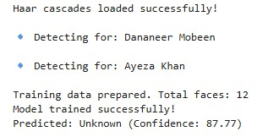

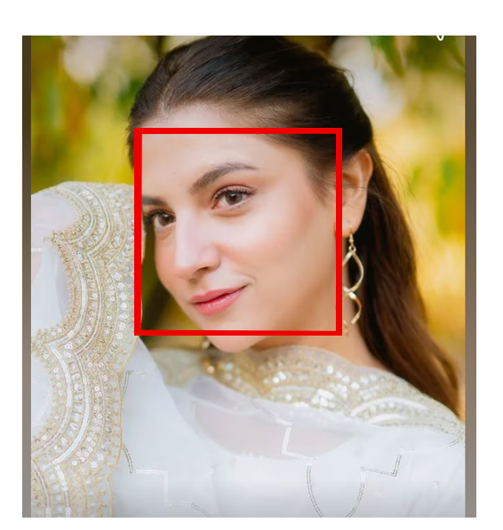

With Built in Functions Code:

import cv2
import numpy as np
import os

# Load Haar Cascade
face_cascade = cv2.CascadeClassifier(
cv2.data.haarcascades + 'haarcascade_frontalface_default.xml'
)

faces = []
labels = []

label_map = {"person1": 0, "person2": 1}

for person in label_map:
folder_path = f"data/{person}"

for img_name in os.listdir(folder_path):
img_path = os.path.join(folder_path, img_name)
img = cv2.imread(img_path, cv2.IMREAD_GRAYSCALE)

if img is None:
continue

detected_faces = face_cascade.detectMultiScale(img, 1.3, 5)

for (x, y, w, h) in detected_faces:
face = img[y:y+h, x:x+w]

# 🔹 FIX: resize all faces to same size
face = cv2.resize(face, (100, 100))

faces.append(face)
labels.append(label_map[person])

# Train recognizer
model = cv2.face.LBPHFaceRecognizer_create()
model.train(faces, np.array(labels))

model.save("trained_faces.yml")

print("✅ Training Completed Successfully")

import cv2

face_cascade = cv2.CascadeClassifier(
cv2.data.haarcascades + 'haarcascade_frontalface_default.xml'
)

model = cv2.face.LBPHFaceRecognizer_create()
model.read("trained_faces.yml")

names = {0: "Person 1", 1: "Person 2"}

cap = cv2.VideoCapture(0)

while True:
ret, frame = cap.read()
gray = cv2.cvtColor(frame, cv2.COLOR_BGR2GRAY)

faces = face_cascade.detectMultiScale(gray, 1.3, 5)

for (x, y, w, h) in faces:
face = gray[y:y+h, x:x+w]
label, confidence = model.predict(face)

name = names[label]

cv2.rectangle(frame, (x,y), (x+w,y+h), (0,255,0), 2)
cv2.putText(frame, name, (x, y-10),
cv2.FONT_HERSHEY_SIMPLEX, 0.9, (0,255,0), 2)

cv2.imshow("Face Recognition", frame)

if cv2.waitKey(1) & 0xFF == ord('q'):
break

cap.release()
cv2.destroyAllWindows()

